Hector SLAM

It was developed for an UGV to compete in 2011 the urban search and rescue competition (USAR) Robocup. As USAR typically include roll and pitch motion along with a structured environment.

It depends on LIDAR measurements. Although the algorithm supports full 3D motion estimation, it performs 2D mapping. It returns a grid map and a pose for every iteration, and saves the trajectory of the robot. The method has been named Hector SLAM.

The underlying principle of Hector SLAM is scan matching. The scan matching procedure used is purpose-designed, based on ideas in images registration for computer vision originally presented in (an alternative image registration matching for stereo vision), namely regarding image matching for stereo vision. The algorithm initializes by writing the first received scan to the map, and subsequent scans are matched with the map by seeking to find the rigid transformation of robot pose that minimizes
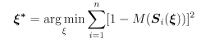

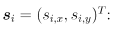
Where Si(xi) are the world coordinates of scan endpoint Si = (Si,x , Si,y)^T

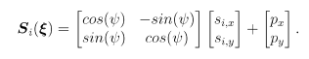

M(Si(xi)) returns the occupancy value of the input world coordinate. With a starting estimate eta given by the navigation filter, the algorithm wants to estimate delta_xi which optimizes the error measure according to
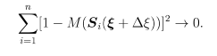

After performing a first ordered Taylor expansion of M(Si(eta + delta_eta)) and minimizing by setting the partial derivative with respect to delta_xi to zero, solving for delta_xi gives the Gauss-Newton equation for the minimization problem:

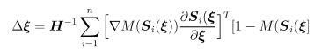

Where the Hessian matrix denotes:

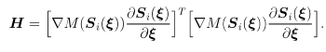

The last two equations both rely on the gradient of the map at some coordinate Pm: nabla_M(Pm). The occupancy value M(Pm) is approximated using bi-linear filtering of the four closest integers representing the midpoints of the map cells of Pm. The interpolation scheme yields:

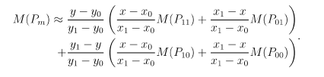

The gradient is then approximated by

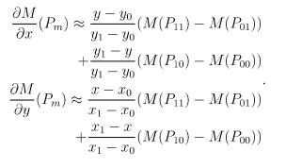

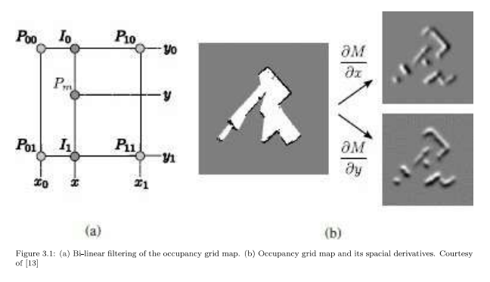
Being a gradient decent-based approach, the scan-matching algorithm has a risk of getting struck in a local minimum, which is a source of error. The method mitigates this through another approach inspired by computer vision – namely image pyramids. Maps are stored at different resolutions,as shown in Figure 3.2. The generation of different resolution is not done by down-sampling, but by producing scaled versions of the current scan. This is more computationally effective and ensures consistency across the layers. The scan matching procedure is performed on all levels of this image pyramid structure. Starting the matching at the coarsest layer, its resulting estimate is used as a starting estimate for the next. eta_hat is assumed to be more precise as the matching works its way towards the final representation. Position data can be used to aid the algorithm in providing a starting estimate for the scan matching through a KF or other fusion methods.

In turn, the odometry result of the scan matcher can be fused with the belief state through covariance intersection (using covariance intersection for SLAM), to maintain the full correlation structure between the robot and the map.

The Hector SLAM does not possess mechanisms to handle loop-closure. Still, the algorithm has shown promise as an accurate and relative to others, quite simple approach to the SLAM.
